CS 305 Project One Template

Document Revision History

Version | Date | Author | Comments
1.0 | 9/23/2025 | Brennen Lawson

Client



Instructions
Submit this completed vulnerability assessment report. Replace the bracketed text with the relevant information. In this report, identify your security vulnerability findings and recommend the next steps to remedy the issues you have found.

- Respond to the five steps outlined below and include your findings.
- Respond using your own words. You may also include images or supporting materials. If you include them, make certain to insert them in the relevant locations in the document.
- Refer to the Project One Guidelines and Rubric for more detailed instructions about each section of the template.

Developer
Brennen Lawson

1. Interpreting Client Needs
Determine your client’s needs and potential threats and attacks associated with the company’s application and software security requirements. Consider the following questions regarding how companies protect against external threats based on the scenario information:

- What is the value of secure communications to the company?
- Are there any international transactions that the company produces?
- Are there governmental restrictions on secure communications to consider?
- What external threats might be present now and in the immediate future?
- What modernization requirements must be considered, such as the role of open-source libraries and evolving web application technologies?

The value of secure communication to the company is extremely high because this is a company that is dealing with customers personal and financial information, so customers social security numbers and their bank account information are on the line among other things as well. If there were to be a breach of some kind, clients could be exposed to identity theft, fraud, and financial loss, and this would also destroy Artemis Financial’s reputation. Customers have to believe that their information is in good hands, especially in the financial industry.

Yes, Artemis Financial does engage in international transactions. This means that they will have to comply with multiple regulatory frameworks and data protection laws round the globe. If they are working with clients from Europe, they will have to follow the GDPR (General Data Protection Regulation) which mandates strict protection of customer data. They will likely also have to follow the ISO/IEC 27001 standards which are relevant for global operations. Some risks to security regarding international transactions include currency exchange, cross-border transactions, and money laundering.

In the US, financial companies and institutions are subject to many regulations. In the FFIEC guidelines, there are specific expectations for cybersecurity in financial institutions. There is also the Sarbanes-Oxley Act, which requires accurate financial reporting and protections against tampering. The Gramm-Leach-Bliley Act requires financial institutions to protect customers financial data (which they should be doing anyways). All of these regulations demand strong encryption, continuous monitoring, secure authentication methods, and audit trails. If a company or institution decides not to comply with these regulations, they run the risk of getting fined, getting sued and/or having a lawsuit filed against them, and even losing licenses.

There is a good number of external threats to consider with Artemis Financial. There is phishing and social engineering, where attackers will target employees or customers to steal credentials and financial information. Since Artemis uses a RESTful API, if there are unsecured endpoints, they could possibly be subject to data theft and injection attacks. There are also Man-in-the-Middle attacks to consider, because without proper encrypted connections, attackers could intercept sensitive financial transactions. There is also SQL injection attacks to consider if there are poorly sanitized input fields that give hackers access to databases. Distributed Denial of Service could overwhelm servers and cause outages which would affect service availability.

If Artemis Financial wants to modernize their operations, then there are many requirements that must be considered. Open source libraries would be good for their upgrade, as it allows for faster development, reduced costs, and gives access to widely tested solutions. But, they should also consider which libraries they are using, because using libraries that are outdated or unpatched could introduce vulnerabilities into their system. Going with the open source libraries, they should run dependency checks and regularly update dependencies, and should also maintain an internal inventory of all third-party libraries used. Another requirement for modernization would be implementing Multi-Factor Authentication for logins. There also needs to be Role-based access controls so that customers and employees can only see what they are authorized to see. Artemis Financial should also do security awareness training for their employees so that they can recognize phishing attempts. They should also consider the deployment of end-to-end encryption for all data in transit and encryption-at-rest for stored customer data.

2. Areas of Security
Refer to the vulnerability assessment process flow diagram. Identify which areas of security apply to Artemis Financial’s software application. Justify your reasoning for why each area is relevant to the software application.

Input Validation is highly relevant. Artemis’s RESTful API and web forms take in client data like login credentials, account information, and transaction details and without proper input validation, attackers could use SQL injection or cross-site scripting to gain access to sensitive data.

APIs are also highly relevant. Because the system relies on a RESTful API to exchange data, if the endpoints are unsecured, attackers could intercept, modify, and/or overload requests.

Cryptography is critical. Considering the fact that Artemis will be engaging in international transactions, cryptography is essential to protect sensitive information in transit and at rest. Weak and/or outdated encryption protocols could expose data.

Client/Server is relevant. Since Artemis will undoubtedly use a web application, it will depend on secure communication between its users and backend servers. If there is poor client/server handling, it can lead to man-in-the-middle attacks and/or session hijacking.

These four areas of security out of the seven seemed most relevant to me. While the other 3 are still technically relevant, they weren’t really on the same level of concern and relevance as the main four.

3. Manual Review
Continue working through the vulnerability assessment process flow diagram. Identify all vulnerabilities in the code base by manually inspecting the code.

- In “GreetingController.java”, there are public and unauthenticated endpoints, which are “@GetMapping(“/greeting”)” and “@RequestMapping(“/read”)”. Anybody could hit these endpoints as there is no authentication and authorization. Since this is expected to reach customer and financial data, this runs a data-exposure and abuse risk. This is an API and Client/Server issue.

- In “GreetingController.java”, there is missing input validation and size limits on request params. “(name request param)” and “(business_name request param)” runs the risk for unbounded and unsanitized input, which has the potential for injection attempts and log pollution. This is an input validation issue.

- In “DocData.java”, there are database credentials in the source code, which is “(DriverManager.getConnection("jdbc:mysql://localhost:3306/test","root","root")”. Stuff like this can be easily leaked and this is a cryptography and code quality issue.

- In the pom.xml file, it uses Spring Boot 2.2.4, which is several years old and is subject to multiple known CVEs. This is a Code Quality, Cryptography, and Client/Server issue.

- In the “application.properties” file, the settings allow for large file-upload without proper validation and storage hardening. This runs the risk for malware upload and DoS. This is an API, input validation, and client/server issue.

- In the “customer.java” file, “account_balance” is package-visible and is mutable without constraints, and “deposit” has no validation, which means that negative values would be possible. This is an encapsulation and code quality issue.

- In the “myDateTime.java” file, “retrieveDateTime()” returns an empty array and the setter does nothing, which is easy to misuse and produces an inconsistent state. This is an encapsulation and code quality issue.

4. Static Testing
Run a dependency check on Artemis Financial’s software application to identify all security vulnerabilities in the code. Record the output from the dependency-check report. Include the following items:

- The names or vulnerability codes of the known vulnerabilities
- A brief description and recommended solutions provided by the dependency-check report
- Any attribution that documents how this vulnerability has been identified or documented previously

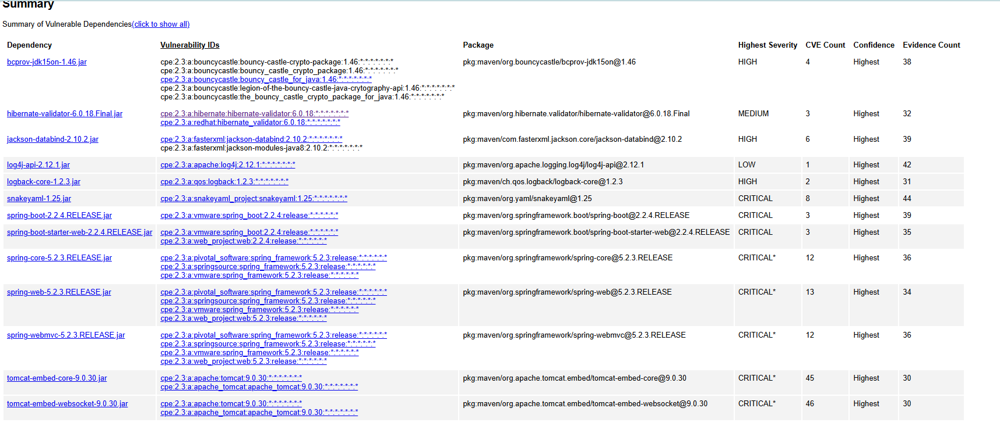

BouncyCastle – bcprov-jdk15on 1.46
CVEs: CVE-2016-1000338, CVE-2020-15522, CVE-2023-33202, CVE-2015-7940
Desc: Old crypto provider with issues leading to info disclosure/DoS in specific algorithms.
Fix: Upgrade to bcprov-jdk15on ≥ 1.78.1 or remove if unused.

Hibernate Validator 6.0.18.Final
CVEs: CVE-2025-35036, CVE-2023-1932, CVE-2020-10693
Desc: Validation bypass/DoS issues in older validator lines.
Fix: Upgrade to 6.2.x or 8.x.

Jackson Databind 2.10.2
CVEs: CVE-2020-25649, CVE-2020-36518, CVE-2021-46877, CVE-2022-42003, CVE-2022-42004, CVE-2023-35116
Desc: Multiple deserialization/DoS flaws across 2.10.x.
Fix: Upgrade to ≥ 2.15.4 or current stable 2.16+/2.17+. Avoid enabling default typing.

Log4j-api 2.12.1
CVEs: CVE-2020-9488
Desc: Resource exhaustion vulnerability (not Log4Shell, still vulnerable).
Fix: Upgrade to ≥ 2.23.x or remove log4j artifacts if not needed.

Logback-core 1.2.3
CVEs: CVE-2023-6378, CVE-2021-42550
Desc: Config processing flaws can lead to unexpected code execution/DoS via malicious configs.
Fix: Upgrade to ≥ 1.4.14 (JDK 11+).

SnakeYAML 1.25
CVEs: CVE-2017-18640, CVE-2022-1471, CVE-2022-25857, CVE-2022-38749/50/51/52, CVE-2022-41854
Desc: Unsafe YAML loading can permit RCE/DoS when parsing untrusted YAML.
Fix: Upgrade to ≥ 2.2 and use safe loaders, and don’t parse untrusted YAML.
Spring Boot 2.2.4.RELEASE (plus transitive Spring Framework 5.2.3)
CVEs: includes CVE-2022-22965 (Spring4Shell) among others.
Desc: Framework request handling/binding vulnerabilities and outdated transitive stack.
Fix: Upgrade parent to Spring Boot 2.7.18 (Java 8/11) or 3.3.x (Java 17+). This lifts Spring/Tomcat/Jackson together.

Tomcat (embedded) 9.0.30 – core and websocket
CVEs: includes CVE-2020-1938 (Ghostcat), CVE-2023-44487 (HTTP/2 Rapid Reset), and many later 9.0.x issues.
Desc: Connector/request processing flaws; AJP exposure; HTTP/2 handling issues.
Fix: Upgrade to Tomcat ≥ 9.0.92 (or current latest 9.0.x). If stuck older, disable AJP and harden connectors.

5. Mitigation Plan
Interpret the results from the manual review and static testing report. Then identify the steps to mitigate the identified security vulnerabilities for Artemis Financial’s software application.

1st step: Upgrade the framework and dependencies by moving to a supported Spring Boot line (2.7.18 or 3.3x) and re-run the dependency-check. This should lift Tomcat, Spring Framework, Jackson, Logback, Hibernate validator, and more. Fix any stragglers by pinning versions if needed.

2nd step: Remove hard-coded database credentials from “DocData.java” and move to “spring.datasource.*”.

3rd step: Secure all endpoints by adding Spring Security and require authentication and authorization for “/greeting” and “/read”.

4th step: Validate input (GreetingController.java) by replacing loose request params with a DTO and Bean Validation. Also, add a global exception handler to return 400 on validation errors.

5th step: Constrain and sanitize file uploads (application.properties) by capping sizes and total request size. Also, restrict content-types and store outside web root.

6th step: Fix “customer.java” encapsulation and money math by making fields private, using “BigDecimal”, validating operations, and prevent negative deposits.

7th step: Replace “myDateTime.java” with a clear API by returning a single, well-typed timestamp and implement the setter or remove it.

